|  |  |
| --- | --- |
| COMPUTER TOOLS  Zohreh Moeini | Srilekha Gollapudi  srilekhagollapudi@gmail.com |

Contents

About Him 1

Early Life and Family 1

Acting Career 2

Early Career 2

Main Stream Film 3

Philanthropy 4

Family 5

# About Him

**Ghattamaneni Mahesh Babu** (born 9 August 1975) is an Indian actor, film producer, media personality, and philanthropist who works in [Telugu cinema](https://en.wikipedia.org/wiki/Telugu_cinema). He is one of the highest-paid actors in [Indian cinema](https://en.wikipedia.org/wiki/Cinema_of_India). He has appeared in more than 25 films, and has won [several accolades](https://en.wikipedia.org/wiki/List_of_awards_and_nominations_received_by_Mahesh_Babu) including, nine [Nandi Awards](https://en.wikipedia.org/wiki/Nandi_Awards), five [Filmfare Telugu Awards](https://en.wikipedia.org/wiki/Filmfare_Awards_South), four [SIIMA Awards](https://en.wikipedia.org/wiki/South_Indian_International_Movie_Awards), three [Cine MAA Awards](https://en.wikipedia.org/wiki/CineMAA_Awards), and one [IIFA Award](https://en.wikipedia.org/wiki/1st_IIFA_Utsavam). He also owns the production house [G. Mahesh Babu Entertainment](https://en.wikipedia.org/wiki/G._Mahesh_Babu_Entertainment). He is referred to in the media and by his fans as "Superstar".

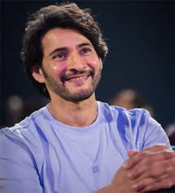

# Early Life and Family

Ghattamaneni Mahesh Babu was born on 9 August 1975 in a [Telugu](https://en.wikipedia.org/wiki/Telugu_people) family to actor [Krishna](https://en.wikipedia.org/wiki/Krishna_(Telugu_actor)) and Indira in [Madras](https://en.wikipedia.org/wiki/Madras), [Tamil Nadu](https://en.wikipedia.org/wiki/Tamil_Nadu), India. He is the fourth of five siblings, after [Ramesh Babu](https://en.wikipedia.org/wiki/Ramesh_Babu), Padmavathi, and [Manjula](https://en.wikipedia.org/wiki/Manjula_Ghattamaneni) and before Priyadarshini. His family hails from [Burripalem](https://en.wikipedia.org/wiki/Burripalem) in [Guntur district](https://en.wikipedia.org/wiki/Guntur_district), [Andhra Pradesh](https://en.wikipedia.org/wiki/Andhra_Pradesh). Mahesh spent his childhood mostly in [Madras](https://en.wikipedia.org/wiki/Chennai) under the care of his maternal grandmother Durgamma and the rest of his family.

He was educated at [St. Bede's Anglo Indian Higher Secondary School](https://en.wikipedia.org/wiki/St._Bede%27s_Anglo_Indian_Higher_Secondary_School). He went on to pursue [Bachelor of Commerce](https://en.wikipedia.org/wiki/Bachelor_of_Commerce) degree from [Loyola College, Chennai](https://en.wikipedia.org/wiki/Loyola_College,_Chennai).

# Acting Career

At the age of four, Babu visited the sets of the Telugu film *Needa* (1979) where its director [Dasari Narayana Rao](https://en.wikipedia.org/wiki/Dasari_Narayana_Rao) shot a few sequences of his as a part of the narrative in the presence of the former's brother Rames. *Needa* marked his debut as a child actor. In 1983, he acted in Poratam (1983) upon being requested by its director [Kodi Ramakrishna](https://en.wikipedia.org/wiki/Kodi_Ramakrishna). He went on to act as a child artist in the films *shankaravam* (1987), [*Bazaar Rowdy*](https://en.wikipedia.org/wiki/Bazaar_Rowdy) (1988), [*Mugguru Kodukulu*](https://en.wikipedia.org/wiki/Mugguru_Kodukulu) (1988) and [*Gudachari 117*](https://en.wikipedia.org/wiki/Gudachari_117) (1989). He played a dual role in the film *Koduku Diddina kapuram* (1989). Babu then appeared in Bala Chandrudu (1990), and [*Anna Thammudu*](https://en.wikipedia.org/wiki/Anna_Thammudu_(1990_film)) (1990).

# Early Career

In 1999, Babu made his debut as a lead actor with the romantic comedy [*Rajakumarudu*](https://en.wikipedia.org/wiki/Rajakumarudu), and people began referring to him with the title Prince. For his performance, he received the Nandi Award for Best Male Debut. He starred in two films the following year – [*Yuvaraju*](https://en.wikipedia.org/wiki/Yuvaraju_(2000_film)) and [*Vamsi*](https://en.wikipedia.org/wiki/Vamsi_(film)). He also starred in [Krishna Vamsi](https://en.wikipedia.org/wiki/Krishna_Vamsi)'s [*Murari*](https://en.wikipedia.org/wiki/Murari_(2001_film)) (2001) which he regarded as an important film in his career and the role he played in it one of his favourites. For his role in *Murari*, he earned a [Nandi Special Jury Award](https://en.wikipedia.org/wiki/Nandi_Special_Jury_Award), in addition to his first nomination for the [Filmfare Award for Best Actor – Telugu](https://en.wikipedia.org/wiki/Filmfare_Award_for_Best_Actor_%E2%80%93_Telugu).

## Main Stream Film

In 2004, Manjula produced his next film,[*Naani*](https://en.wikipedia.org/wiki/Naani), directed by [S. J. Surya](https://en.wikipedia.org/wiki/S._J._Surya) co-starring [Amisha Patel](https://en.wikipedia.org/wiki/Amisha_Patel). While its simultaneously shot Tamil version [*New*](https://en.wikipedia.org/wiki/New_(film)) featuring a different cast proved to be commercially successful, *Naani* flopped at the box office. He received his third Nandi Special Jury Award for his performance in his next film, [*Arjun*](https://en.wikipedia.org/wiki/Arjun_(2004_film)), directed by Gunasekhar and produced by Ramesh. The film released on 18 August 2004 and was successful at the box-office. The film was screened at the [International Film Festival of India](https://en.wikipedia.org/wiki/International_Film_Festival_of_India) in the mainstream section. This was Keerthi Reddy's final acting performance prior to her retirement from the film industry. He chose to act in [Trivikram Srinivas](https://en.wikipedia.org/wiki/Trivikram_Srinivas)'s [*Athadu*](https://en.wikipedia.org/wiki/Athadu) (2005), co-starring [Trisha Krishnan](https://en.wikipedia.org/wiki/Trisha_Krishnan), whose script had been approved back in 2002 before the production of *Naani* and *Arjun* had begun. It emerged as one of the highest-grossing films of the year. The film proved to be a major boost for Babu's career as he received his fourth nomination for the Filmfare Award for Best Actor – Telugu, in addition to fetching his second Nandi Award for Best Actor for his performance in the role of a hired assassin. The movie collected a share of ₹22 crores at the box office. [*Idlebrain.com*](https://en.wikipedia.org/wiki/Idlebrain.com) gave it a rating of 3.25/5 and mentioned Mahesh Babu is stylish and brilliant as professional killer. *Cinegoer.net* gave a review stating, "True the film gives an image of a [Hollywood](https://en.wikipedia.org/wiki/Hollywood_film) base for the drama. Even the taking, screenplay structure and execution of scenes, less talk and more action.

# Philanthropy

Mahesh Babu established, "Mahesh Babu Foundation", to improve the lives of underprivileged children and communities. The foundation primarily focuses on supporting children in need by funding life-saving [congenital heart surgeries](https://en.wikipedia.org/wiki/Congenital_heart_defect). The foundation also co-runs the charitable trust and non-profit organisation "Heal A Child" in collaboration with Andhra Hospitals and [Rainbow Hospitals](https://en.wikipedia.org/wiki/Rainbow_Hospitals). It also recognises the importance of education and provides [scholarships](https://en.wikipedia.org/wiki/Scholarship) to meritorious students from underprivileged backgrounds. Recognizing the need for holistic development, the Mahesh Babu Foundation adopted two villages, [Burripalem](https://en.wikipedia.org/wiki/Burripalem) in [Andhra Pradesh](https://en.wikipedia.org/wiki/Andhra_Pradesh) and [Siddhapuram](https://en.wikipedia.org/wiki/Siddhapuram,_Nalgonda_district) in [Telangana](https://en.wikipedia.org/wiki/Telangana). In these villages, the foundation has undertaken various initiatives to improve the quality of life, including constructing schools, Anganwadi buildings, libraries, roads, and drainage systems. Additionally, they have established computer labs to equip villagers with crucial digital skills. The foundation also conducts regular medical checkups, distributes medicines to those in need, and has fully vaccinated the entire population of the adopted villages against [COVID-19](https://en.wikipedia.org/wiki/COVID-19). Through health awareness programs, the foundation strives to empower villagers to make informed decisions about their well-being.

# Family

Mahesh Babu married his co-star [Namrata Shirodkar](https://en.wikipedia.org/wiki/Namrata_Shirodkar) on 10 February 2005 at [Marriott Hotel](https://en.wikipedia.org/wiki/Marriott_Hotel), Mumbai during the shooting of [*Athadu*](https://en.wikipedia.org/wiki/Athadu) (2005). They have one so and one daughter

Mahesh is the fourth child in a family of five children. His elder brother [Ramesh Babu](https://en.wikipedia.org/wiki/Ramesh_Babu) was a film producer and was also an actor. Mahesh Babu's eldest sister Padmavathi is married to [Galla Jayadev](https://en.wikipedia.org/wiki/Galla_Jayadev), an industrialist and [Member of the Indian Parliament](https://en.wikipedia.org/wiki/Indian_Parliament) from the [Telugu Desam Party](https://en.wikipedia.org/wiki/Telugu_Desam_Party). His elder sister [Manjula](https://en.wikipedia.org/wiki/Manjula_Ghattamaneni) is a film producer, director, and an actress. Priyadarshini, his younger sister, is married to [Sudheer Babu](https://en.wikipedia.org/wiki/Sudheer_Babu), who later made his debut as an actor in Telugu cinema.

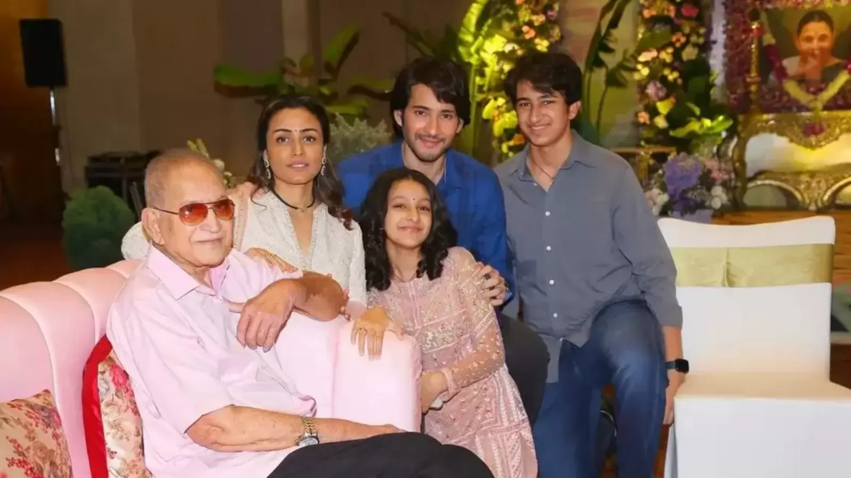

# Table

|  |  |
| --- | --- |
| **Category** | **Food Item** |
| Baked Goods | Apple crisp, homemade |
| Baked Goods | Biscuit, plain or buttermilk, from mix, baked |
| Baked Goods | Muffin, fruit, commercial |
| Beverages | Cola |
| Beverages | Sangria |
| Beverages | Cola, aspartame sweetened |
| Dairy | Cheese, Brick |
| Dairy | Cheese, Brie |
| Dairy | Cheese, Cheddar |
| Fast Foods | Breakfast English muffin with egg, cheese and bacon |
| Fast Foods | Cheeseburger, double patty + condiments + vegetables |
| Fast Foods | Chicken fried rice |